
North Bengal International University

Lab Report: 04

Exp Name : Implementation of Signed Binary Multiplication Using Bit-wise Operator Language

Subject : Computer Architecture & Organization Sessional
Subject Code : CSE 0612-3142

Submitted By:
Name : Md. Tanvir Rahman Pranto
Dept : CSE
Roll : 0712340012101005
Semester : 2nd Year, 4th semester.

Submitted To:
Name : Md. Shafiuzzaman
Designation : Lecturer
Dept : CSE
Date :

Experiment No: 04
Experiment Name: Implementation of Signed Binary Multiplication Using Bit-wise Operator in C Language
Theory: Signed binary multiplication involves multiplying two numbers (positive or negative) in binary format. Computers use two’s complement to represent negative numbers. Instead of using the built-in * operator, we can simulate multiplication by checking each bit of the multiplier and adding the shifted multiplicand when necessary. Bitwise operators like <<, >>, and & help in performing this multiplication, which closely mimics how hardware arithmetic units work internally. This is an essential concept for understanding how basic operations are performed in computer architecture.
Code:
#include <stdio.h>

int main() {
int a, b, result = 0;
int negative = 0;

printf("Enter first number: ");
scanf("%d", &a);

printf("Enter second number: ");
scanf("%d", &b);

if (a < 0) {
a = ~a + 1;
negative = !negative;
}

if (b < 0) {
b = ~b + 1;
negative = !negative;
}

while (b != 0) {
if (b & 1) {
result += a;
}
a <<= 1;
b >>= 1;
}

if (negative) {
result = ~result + 1;
}

printf("Product is: %d\n", result);

return 0; }
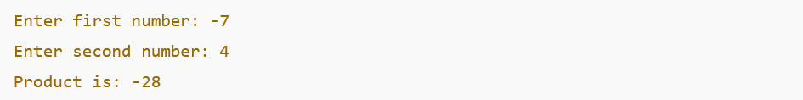
Output:

Conclusion: This lab showed how signed multiplication can be done using bitwise operations, helping us understand low-level binary arithmetic in computer architecture.

